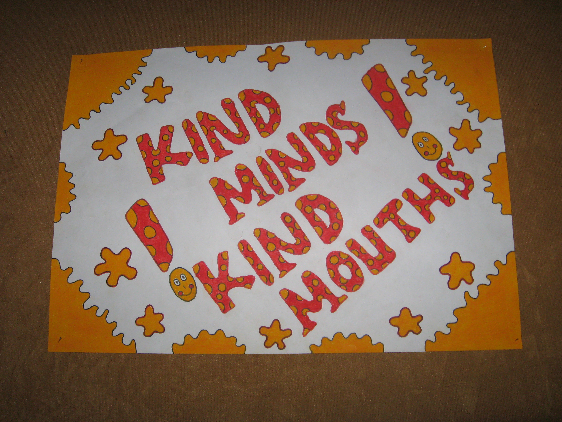
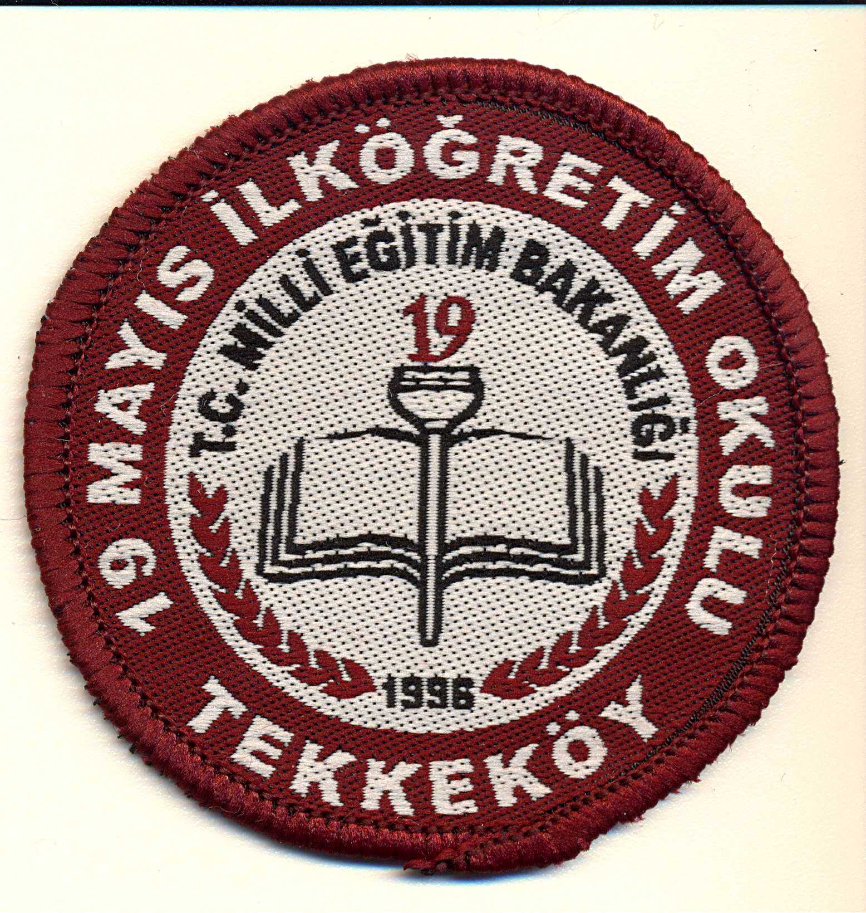
19 MAY PRIMARY SCHOOL PROJECT MEETING PROGRAM
“KIND MINDS-KIND MOUTH” Samsun,29 May-02 June 2012
Day | Morning | Afternoon | Evening
Tuesday  29th May 2012 | Arrival of participants  Transfer from airport to the hotel  (Note:Will be planned after getting the ecxact flight time) | Arrival of participants  Transfer from airport to the hotel  (Note:Will be planned after getting the ecxact flight time) | 19:00  Welcome Diner  at Deniz Cafe  (You are the guest of 19 May Primary School)
Wednesday  30th May 2012 | 9:00-14:30  Project Meeting  -Meeting with the staff  -Presentation of the School  -English-Turkish Class to the teachers  -Visiting Classes  -Round Table Meeting for Evaluating the Finalization of the Project,reports of the Project result.  -Organizing materials for creating the DVD of the Project and for the Web-site | 15:00  -Lunch at Midilli Restaurant  (You are the guest of 19 May Primary School)  (drinks are extra)  17:00  -Cultural Program(visiting the city museum and Atatürk’s House) | 20:00  -Dinner at Öğretmenevi  ( 8-10 Euro)
Thursday  31st May 2012 | 9:30 Transfer from Hotel  10:30-13:00 Boat Trip  (You are the guest of 19 May Primary School,drinks are extra) | 14:00  -Lunch at Amisos Restaurant and visiting historical ruins (10 Euro)  16:00-Coffee Time in Atakum | 19:00  -Dinner at Pamuk Kardeşler Restaurant  (15 Euro)
Friday  1st June 2012 | 8:30  -Visiting Amasya (Cultural program)  …  (You are the guest of 19 May Primary School) | 13:30  -Lunch at Strabon Restaurant (8 Euro)  14:30  -Visiting Borabay Lake | 20:00  -Dinner in Samsun  Beyazev Restaurant  (8 Euro)
Saturday  2nd june 2012 | 10:00  Final Meeting  12:00 –Free Time (Shopping,…) | Departure of Participants  -Transfers will done accordingly
(Note:Transfers will be done by us)

